

**Matrix Release Notes**

All intellectual property rights in relation to the software product herein and its secondary works (including but not limited to copyright, trademark and know-how) and all documentation (including all the information in this document together with any exhibits or annexes) related to the foregoing shall belong to Matrix (China) Co., Ltd ("Matrix") under any circumstances.

The information in this document is confidential and meant for internal use only by the intended recipients of the users. Any user of this document shall not disclose, lend, grant license, transfer, sell, distribute, circulate, or conduct any other disposals in relation to the software product and this document, without prior written approval from Matrix, to any third party (including but not limited to the user's officers, employees and affiliated companies other than the intended recipients of the user), and shall not let such third party use the software product and information included in this document in any form.

Copying, modifying, or distributing this document in any form or by any means for any purpose without prior written permission of Matrix is expressly prohibited. Any user of this document shall not alter, remove, or tamper with any trademarks used in this document.

This document is provided "as is" and Matrix does not warrant, guarantee, or make any representations regarding the use, or the results of the use, of this document in terms of correctness, accuracy, reliability, or otherwise. All the information in this document are subject to further change without any notice, and Matrix shall not be liable for any errors or inaccuracies that may appear in this document.

In no event shall Matrix be liable for any direct, indirect, incidental, special, exemplary, or consequential damages (including, but not limited to, procurement of substitute goods or services, loss of use, data, or profits; or business interruption), liability, or tort (including negligence or otherwise) arising out of or resulting from the use of the software product and information included in this document, even if advised of the possibility of such damage.

Software of certain third parties might be carried incorporated in Matrix product. For more details, please see the copyright statement in the third party's software documents.

Copyright© Matrix (China) Co., Ltd. All rights reserved.

# Contents

Contents III

Release Info IV

1 Abstract I

2 Concept II

2.1 Full Node II

2.2 Master Node II

2.3 GroupList II

3 Key Points III

3.1 Cryptography III

3.2 P2P Connection III

3.3 Communication III

# Release Info

| Release Date | Version No. | Description | Author |
| --- | --- | --- | --- |
|  | 0.1 | Proof of Concept | Matrix |
|  |  |  |  |

# **Abstract**

This document contains release notes for the new features in the first release of Matrix’s product.

Document generated on: 2018-4-28

# **Concept**

## **Full Node**

Full node involves Bitcoin Wallet, Miner Node, the whole BlockChin database as well as Network Routing

## **Master Node**

We can consider master node as a full node with specified amount of deposits in its associated wallet.

## **GroupList**

This file provides information about the claimed computing power of nodes, as well as the grouping of 9 hosts used for testing.

# **Key Points**

## Cryptography

We will replace **esdca** cryptographic method with National level cryptographic algorithms for cryptography.

## **P2P Connection**

We will introduce a P2P connection module to ensure that communication, [synchronization](http://dict.cn/synchronization) and collaboration could go well between those hosts, and new connections can be established via existing decision making capability.

## Communication

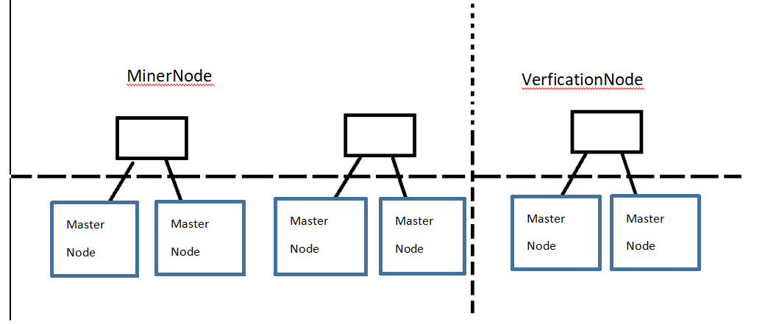Figure 1 Network Chart

Once the hosts acting as master nodes starts, they will begin mining immediately, and add the IP and Computing Power information to the grouplist;

When new nodes joins the network, UDP connection will be established between nodes. In such case, if the number of nodes reaches a specified value in the network, they will be divided into different groups based on the number of nodes in the grouplist. Then, the election algorithm will run to determine which node will be miner node (a role for assigning tasks) or which one will be verification node (specifically for verification purpose).

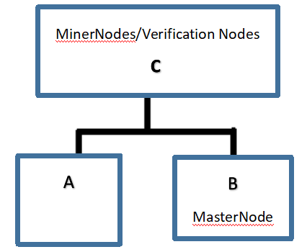

Figure 2 Node Levelling

After that, a [synchronization](http://dict.cn/synchronization) of chain information between miner/verification node and the other nodes will be performed, in order to keep the chain storage information of the current node consistent with that of miner node: a TCP connection will be created between the miner node and its child nodes, to synchronize all the information to the child nodes.

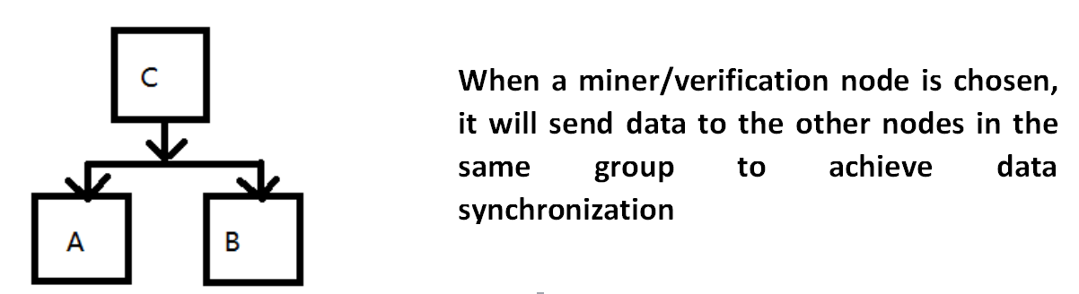

Figure 3 Block Information Synchronization

After mining is completed successfully, a broadcast will be send out throughout the communication network. The broadcast will send the information of new nodes by traversing the grouplist and establishing a TCP connection with each node. After the master node receives the information, the new blocks will be added into the block chain.

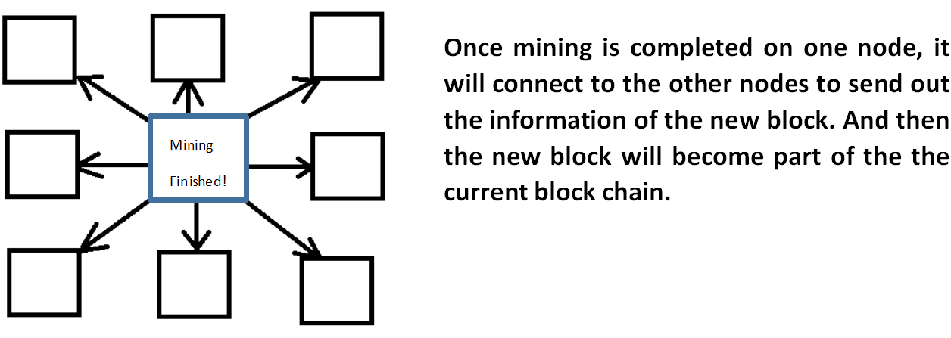

Figure 4 Broadcast upon new block generation